**PURPLE TEAM – Willson Financial Case Study**

**Milestone #2**

**Revised ERD:**

**Changelog:**

12/1/2022

Added Transaction_ID to Transaction Table - Transactions all have a transaction number - this will be the transaction id

Added Transaction_Type to Transaction Table - is the customer adding assets, transferring assets, removing assets?

Changed customer to client (since that is how they are referred to in the case study prompt)

Added client address and client phone number to client table

Added Employee_Address and Employee_Phone_Number to Employee Table

(Dont think we need the employee table or the job table - from what I read they just want to know about customers transactions and assets

nothing mentioned in the prompt about employees other than them hiring a couple. I could be wrong.)

To init file: added ‘date_added’ field to client/customer table

**3NF:**

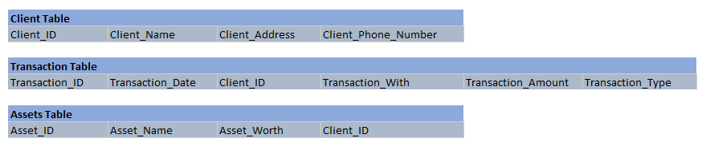

**Display Screen Shots:**

